Reimaging Kaskaskia:
An ARC-GIS Study of the First Capital of Illinois

Dr. Mark J. Wagner
Director, Center for Archaeological Investigations
mjwagner@siu.edu
618-453-5055

Introduction

We propose to use student-generated archival map and Geographic Information System (GIS) mapping to relocate the now vanished historic town of Kaskaskia in Randolph County, Illinois on the existing land surface (Figure 1). Established in 1703 as a French mission, Kaskaskia grew into a trading and agricultural community during the French colonial period (1673-1765) (Figure 2). Kaskaskia later served as the territorial (1803-1818) and state capitol (1818-1819) of Illinois during the American period (Figure 3). Located at the confluence of the Kaskaskia and Mississippi Rivers, Kaskaskia was heavily impacted by a shift in the course of the Mississippi River in 1881 when that river broke into the streambed of the Kaskaskia River. Over the next 20 years the river steadily eroded the eastern edge of Kaskaskia, reducing the community to a ghost town of a few collapsed buildings by 1900.

Project Rationale

Historians have long assumed that the Kaskaskia was completely destroyed by ca. 1900 (Belting 1948; Macdonald and Waters 2019). Although true from an architectural standpoint, historic period archaeological sites are known to exist on Kaskaskia Island (Linder 1975; Moffat and Anderson 1984). As the Mississippi River primarily impacted the east side of Kaskaskia, it is possible that some of these represent the remains of structures located at the northern and western edges of the town. Plotting the location of Kaskaskia on the modern landscape via GIS software (ArcGIS) may help resolve this issue and serve as “proof of concept” for further investigation into the archaeological remains of Kaskaskia.

Historic Background of Kaskaskia

Kaskaskia was established on present-day Kaskaskia Island (Figure 1) as a Jesuit mission in 1703. Over the next 60 years it became a major French political and economic center within Illinois. It retained its importance into the early nineteenth century when it became the territorial capital (1809-1818) and first state capital (1818-1819) of Illinois. Significant episodes in the history of the town included the visit of the Marquis de Lafayette in 1824 as well as one by Meriwether Lewis and William Clark during the initial stages of the Lewis and Clark Expedition in 1803. Kaskaskia continued to exist until 1881 when the Mississippi River, originally located west of the town, broke through into the channel of the Kaskaskia River, which bordered the town to the east. Over the next two decades the river steadily eroded the river bank bordering the town, until only a few standing structures remained By A.D. 1900 Kaskaskia had become to all intents and purposes a ghost town (MacDonald and Waters 1991).

Spatial Organization of Historic Kaskaskia

By the 1760s Kaskaskia had assumed the typical pattern of a colonial French town with a central street grid of approximately 30 irregular lots of various sizes flanked to the north and south by “common fields” shared by the people of the community (Figure 2; Pittman 1770). Based on the measurements on Phillip Pittman’s 1765 map, the community extended back (west) of the Kaskaskia River for approximately 3600 ft or 1.68 mi (1.09 km). A later map from the 1850s indicates that the street grid had changed to a more formalized American-style pattern of 42 roughly equal sized blocks by the mid-1800s (Figure 3). The town appears to have maintained its northern and southern boundaries but may have extended farther back (west) from the Kaskaskia River than it did in the 1760s. Although specific information is lacking, we assume that the town maintained this type of spatial organization until the 1881 flood.

Present Day Appearance

Kaskaskia Island today consists of a combination of privately owned agricultural fields and land holdings managed the St. Louis Corps of Engineers (COE) and the U.S. Fish and Wildlife Service. The suspected former location of the town has been designated as the Kaskaskia and Mississippi River Confluence Heritage Area by the COE (Figure 1). As noted previously, archaeological sites containing both prehistoric and historic artifacts are known to exist in this area (Linder 1975; Moffat and Anderson 1984) indicating that portions of the original ground surface near or at Kaskaskia survived the ca. 1881-1900 destruction of the town.

Project Research Design

We propose to train undergraduate students to investigate the possibility that archaeological remains of the town of Kaskaskia still exist on Kaskaskia Island. They will (1) conduct research into primary sources to locate archival maps of Kaskaskia and (2) create a map using GIS software (ArcGIS), georeferencing the archival maps to the modern landscape to identify the former boundaries of the town.

Primary research will be conducted by the project director (Dr. Wagner) and the students at the Abraham Lincoln Presidential Library in Springfield, Illinois, to locate archival maps of Kaskaskia that can be photographed or scanned in (Figure 3). Such a visit will require CAI researchers and staff to travel to Springfield to conduct the research and possibly stay overnight. Research also will be conducted on line to locate additional maps of the town that may be available on line

Following the acquisition of the historic maps, Dr. Ryan Campbell of the CAI will train the students in the use of Esri’s ArcGIS software and oversee their work during the use of the software. The students involved in this project will learn to import the historic maps into ArcGIS and align them to features on the modern landscape (georeferencing) by searching for shared points in LiDAR imagery, satellite photography, and modern maps. Once the maps have been aligned, a series of polygon layers representing the location of old roads, buildings, and the town boundaries will be created. These layers will be exported as shapefiles that can be shared with the federal and state agencies that manage or oversee archaeological resources on Kaskaskia Island.

CIA staff and also students will travel to Kaskaskia Island from Carbondale on one or more day trips to obtain information on the present-day physical condition of the former location of the town of Kaskaskia.

The CAI also will share the results of the project including GIS overlays to the two federal agencies—the US COE and the US F&WS—with land holdings on Kaskaskia Island to make them aware of this information and aid in the preservation of any archaeological resources on Kaskaskia Island. The information also will be shared with the Illinois State Historic Preservation Office (SHPO) and the Illinois State Museum (ISM), which maintains the database containing all archaeological site information within Illinois

Table 1. Project Schedule/Timeline

July 1, 2022 | Selection of Students to work on project
July 1-30, 2022 | Research by students to locate institutions holding archival maps of Kaskaskia
August 1-30, 2022 | Visit to Kaskaskia Island to obtain information on current appearance of landscape
September 1-30, 2022 | Travel to archives to locate and scan maps of Kaskaskia
October 1-30, 2022 | Instruction of students in ArcGIS by Dr. Ryan Campbell
November 1-30, 2022 | Creation by students of poster for presentation at professional meetings
December 1, 2022 –  January 30, 2023 | Presentation by students of poster at professional meetings
February 1 –  April 30, 2023 | Present results of project to federal and state agencies.
May 1-30, 2023 | Submit ARC GIS overlays to the Illinois Archaeological Survey site files
June 1-30, 2023 | Submittal of Final Report to SIU VCR office and SIU Foundation

Project Outcomes

Student Success

This project will aid in student success by providing them with skills that will aid them in finding employment or admittance to graduate school after graduation including:

(1) Geographic Information System (GIS) – The use of GIS software is becoming increasingly important to state and federal agencies that deal with large amounts of archaeological, botanical, faunal, and other data on lands that they administer. As such, students with a knowledge of ArcGIS will have a greater chance of obtaining employment than those who do not.

(2) Archival Research - Many undergraduates are unfamiliar with the types of resources housed at state and federal archives and how to research them. Students employed on this project will obtain experience in doing archival research that may aid them in applying to graduate school or obtaining employment with agencies that conduct such research after graduation.

(3) Presentations at Professional Meetings – It has been our experience that many undergraduates have never been to a professional conference or made a poster or oral presentation at such conferences. This project will provide the students working on it with such an opportunity, which may aid them in applying to graduate school or finding employment after graduation.

Publication of Project Results

We anticipate publishing the results of the project in Illinois Archaeology, which is the journal of professional archaeologists in Illinois, with the students as co-authors.

Dissemination of Project Results to State and Federal Agencies

We will submit the GIS data the Illinois State Museum (ISM) so that it can be used to create a layer in the state archaeological site database showing the location of the town of Kaskaskia on the modern landscape. This will help protect the sit by making researchers and agency officials aware of its location.

Raising the Research Profile of SIUC

As the first capital of Illinois, the town of Kaskaskia continues to be an object of scholarly research as demonstrated by a recent history of Kaskaskia (MacDonald and Waters 2019). The demonstration by the proposed project that parts of Kaskaskia potentially still survive as archaeological remains will receive widespread interest by researchers and throughout the state.

Project Personnel

Project personnel will consist of Dr. Mark Wagner (CAI Director) and Dr. Ryan Campbell (Assistant CAI Director). Dr. Wagner will work with the students to conduct the archival research while Dr. Campbell will instruct them in ArcGIS. Dr. Wagner and Campbell have been conducting archaeological and historical research at Forts Kaskaskia I (11R326) and II (11R612) since 2017 as well as giving presentations on this research at professional meetings (Wagner 2018, 2021). Undergraduate students who work on the project will selected from those enrolled under Dr. Wagner in Anthropology 442 (Working With Archaeological Collections) or 460 (Individual Study in Anthropology or 465 (Internship).

References

Belting, Natalia Marie
1948 Kaskaskia Under the French Regime. University of Illinois Press, Urbana.

Linder, Jean
1975 Survey of the Archeological Resources Along the Existing and Proposed Levees on Kaskaskia Island in Randolph County, Illinois, and Ste. Genevieve, Missouri. Report Submitted to the Corps of Engineers, St. Louis District, in partial fulfillment of the provisions of Contract No. LMSSD 75-2769.

MacDonald, David and Raine Waters
2019 Kaskaskia: The Lost Capital of Illinois. SIU Press, Carbondale.

Moffat, Charles
1984 Test Excavations at Three Archaeological Sites on Kaskaskia Island. Cultural Resource Management Report no. 12, U.S. Army COE, St. Louis District.

Pittman, Phillip
1770 The Present State of the European Settlements on the Mississippi. J. Nourse, London.

Wagner, Mark J.
2018 Searching for the Lewis and Clark Expedition at Ft. Kaskaskia, Illinois. Paper presented at the 51st Conference on Historical and Underwater Archaeology, New Orleans, La., January 3-6, 2018.

2021 Bound to the Western Waters: Searching for Lewis and Clark at Fort Kaskaskia, Illinois. We Continued On 47:1:23-29.

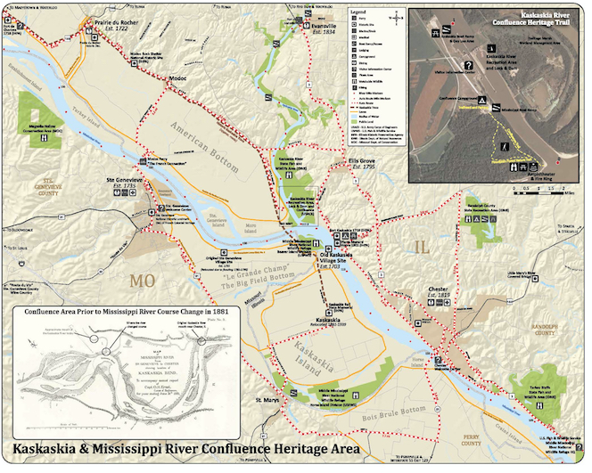

Figure 1. Map of Kaskaskia and Mississippi River Confluence Area Showing
Location of Kaskaskia Island (Bottom, Center).

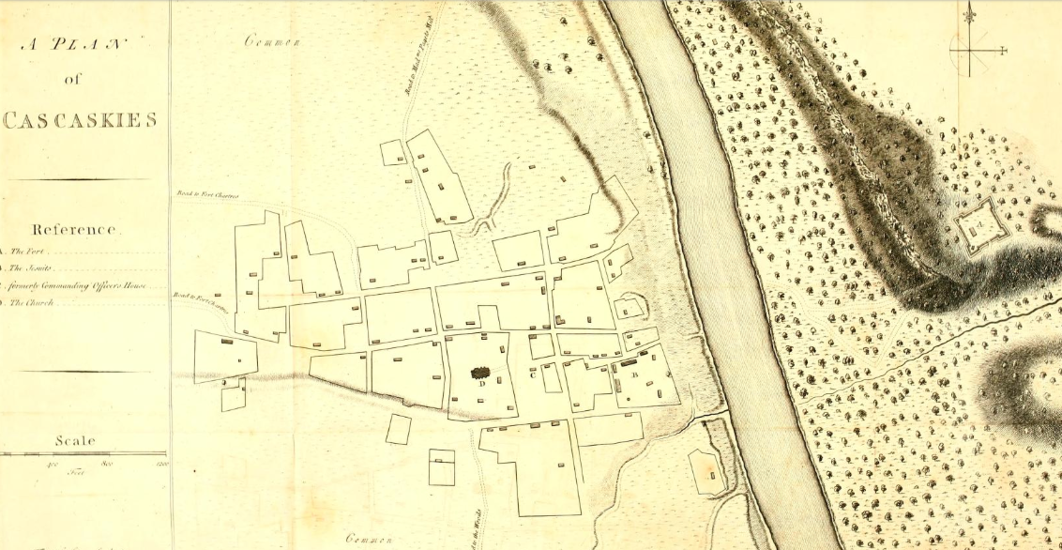

Figure 2. 1765 Map of French Colonial Kaskaskia showing street grid and structures

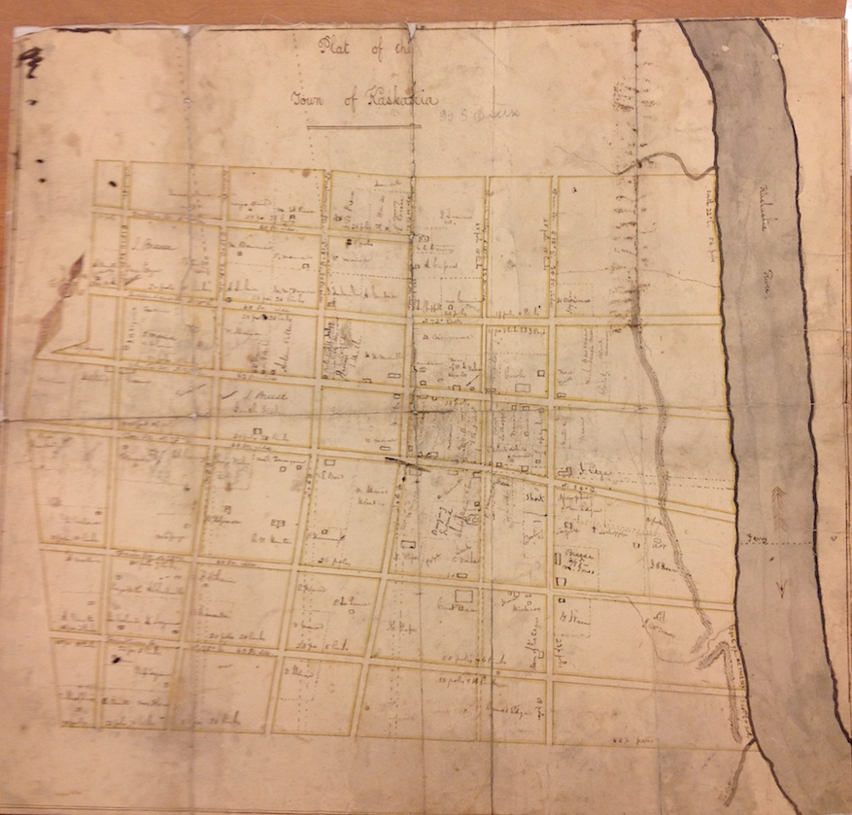Figure 3. Unpublished mid-1800s Sidney Breese map of Kaskaskia showing street grid in relation to Kaskaskia River.

