JOB AID: CITI SINGLE SIGN ON (SSO) AND ACCOUNT SET-UP INSTRUCTIONS
The SIUC SSO is a secure process that lets you access the CITI online research compliance and safety training portal using your SIUC login ID. SSO logins eliminate the burden of creating and managing separate credentials while maintaining security.
Note: This job aid is for existing and new CITI users who are affiliated with Southern Illinois University Carbondale and have a valid SIUC email address and network account. If you need to request a non-SIUC user account for an outside collaborator, email the Office of Research Compliance at orc@siu.edu.

Step 1: In your internet browser, navigate to the CITI homepage https://citiprogram.org and select “log in” from the top upper right corner.

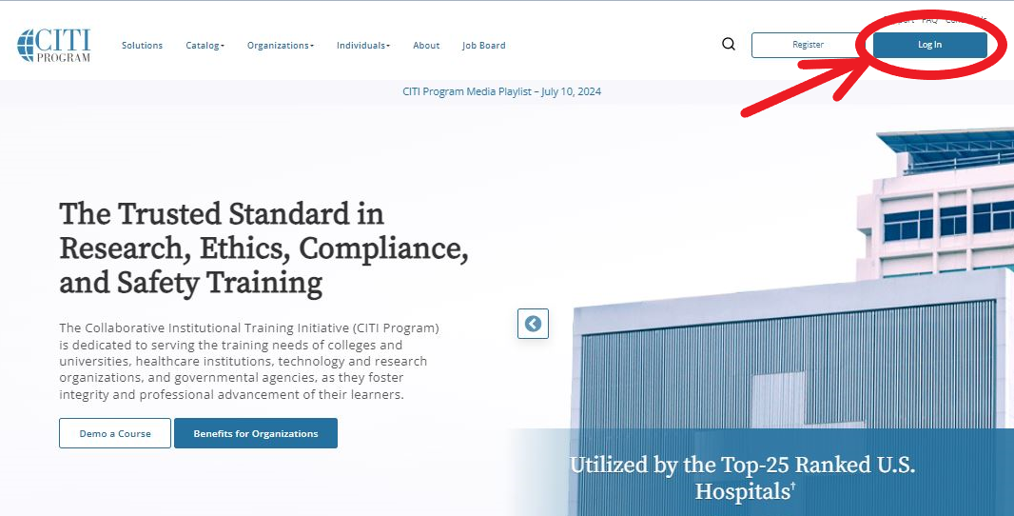

Step 2: Select “log in through my organization.”
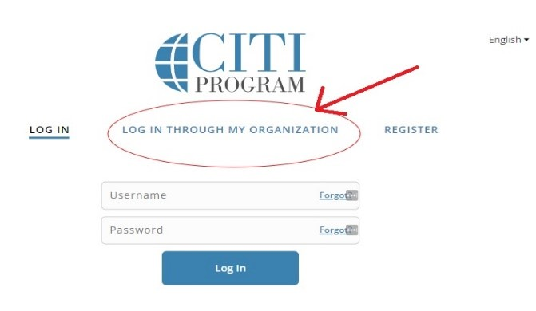

Step 3: Locate and select Southern Illinois University Carbondale from the organization list.

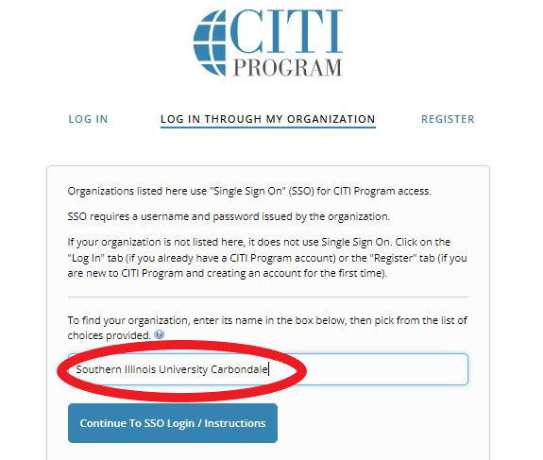

Step 4A (Existing Accounts): ***New CITI users, skip to step 4B*** When first logging in via SSO, if you are not automatically matched with your account, CITI will prompt you to match your existing account. Existing users will select “I already have a CITI program account” and enter their CITI username and password.

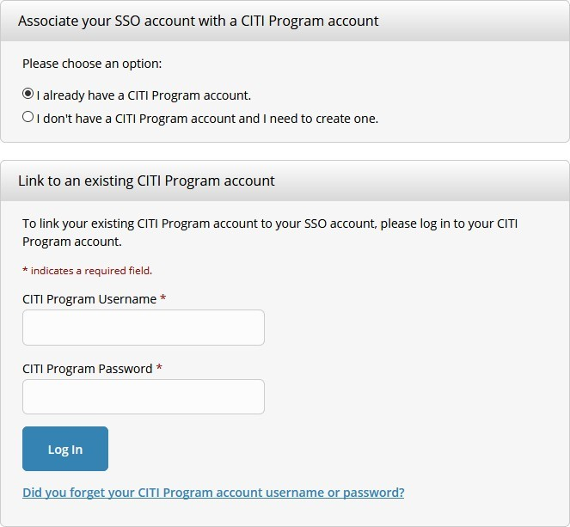

You will only have to do this once. Next time you log-in via SSO, you will be automatically logged into your CITI Program account.

Step 4B (New Account Creation): New users should choose the “I don’t have a CITI Program account and I need to create one.” Follow the prompts to create your new account.
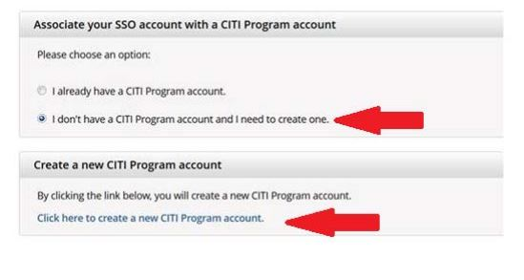
Step 5: Select, Add, and/or complete training modules.

New users are automatically routed to the course selection screen. Existing users can add courses by navigating to “my courses” page and selecting “learner tools.”

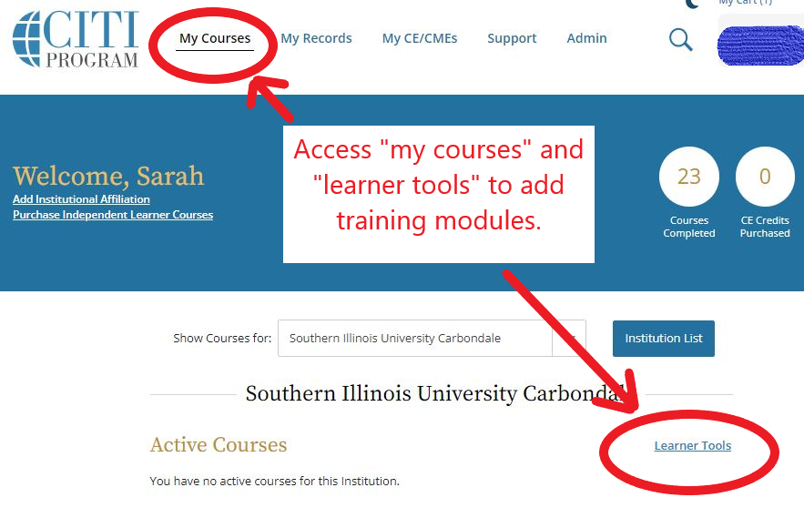

For additional information on required training modules for human subjects research, research with animals, conflicts of interest and responsible conduct of research, visit: https://orc.siu.edu/training-resources.php

